Linux Operating System Overview
Introduction to Linux
Linux is an open-source, Unix-like operating system kernel that forms the foundation of many modern operating systems. It is widely used across desktops, servers, cloud platforms, mobile devices, and embedded systems due to its stability, security, scalability, and performance. Linux allows users to freely access, modify, and distribute its source code, which encourages innovation and collaboration. Its modular design enables customization for diverse computing needs, ranging from lightweight personal systems to large-scale enterprise infrastructures. Today, Linux powers most web servers, supercomputers, cloud services, and Android devices, making it a critical component of modern computing.
Linux History and Philosophy
Linux was created in 1991 by Linus Torvalds as a personal project aimed at developing a free and open alternative to proprietary operating systems. Over time, it evolved into a global collaborative effort, with contributions from thousands of developers worldwide. The philosophy of Linux is deeply rooted in open-source principles such as freedom, transparency, collaboration, and community-driven development. Linux emphasizes user control, encourages knowledge sharing, and supports continuous improvement through peer review. This philosophy has led to rapid innovation, high reliability, and widespread adoption across industries and academic institutions.
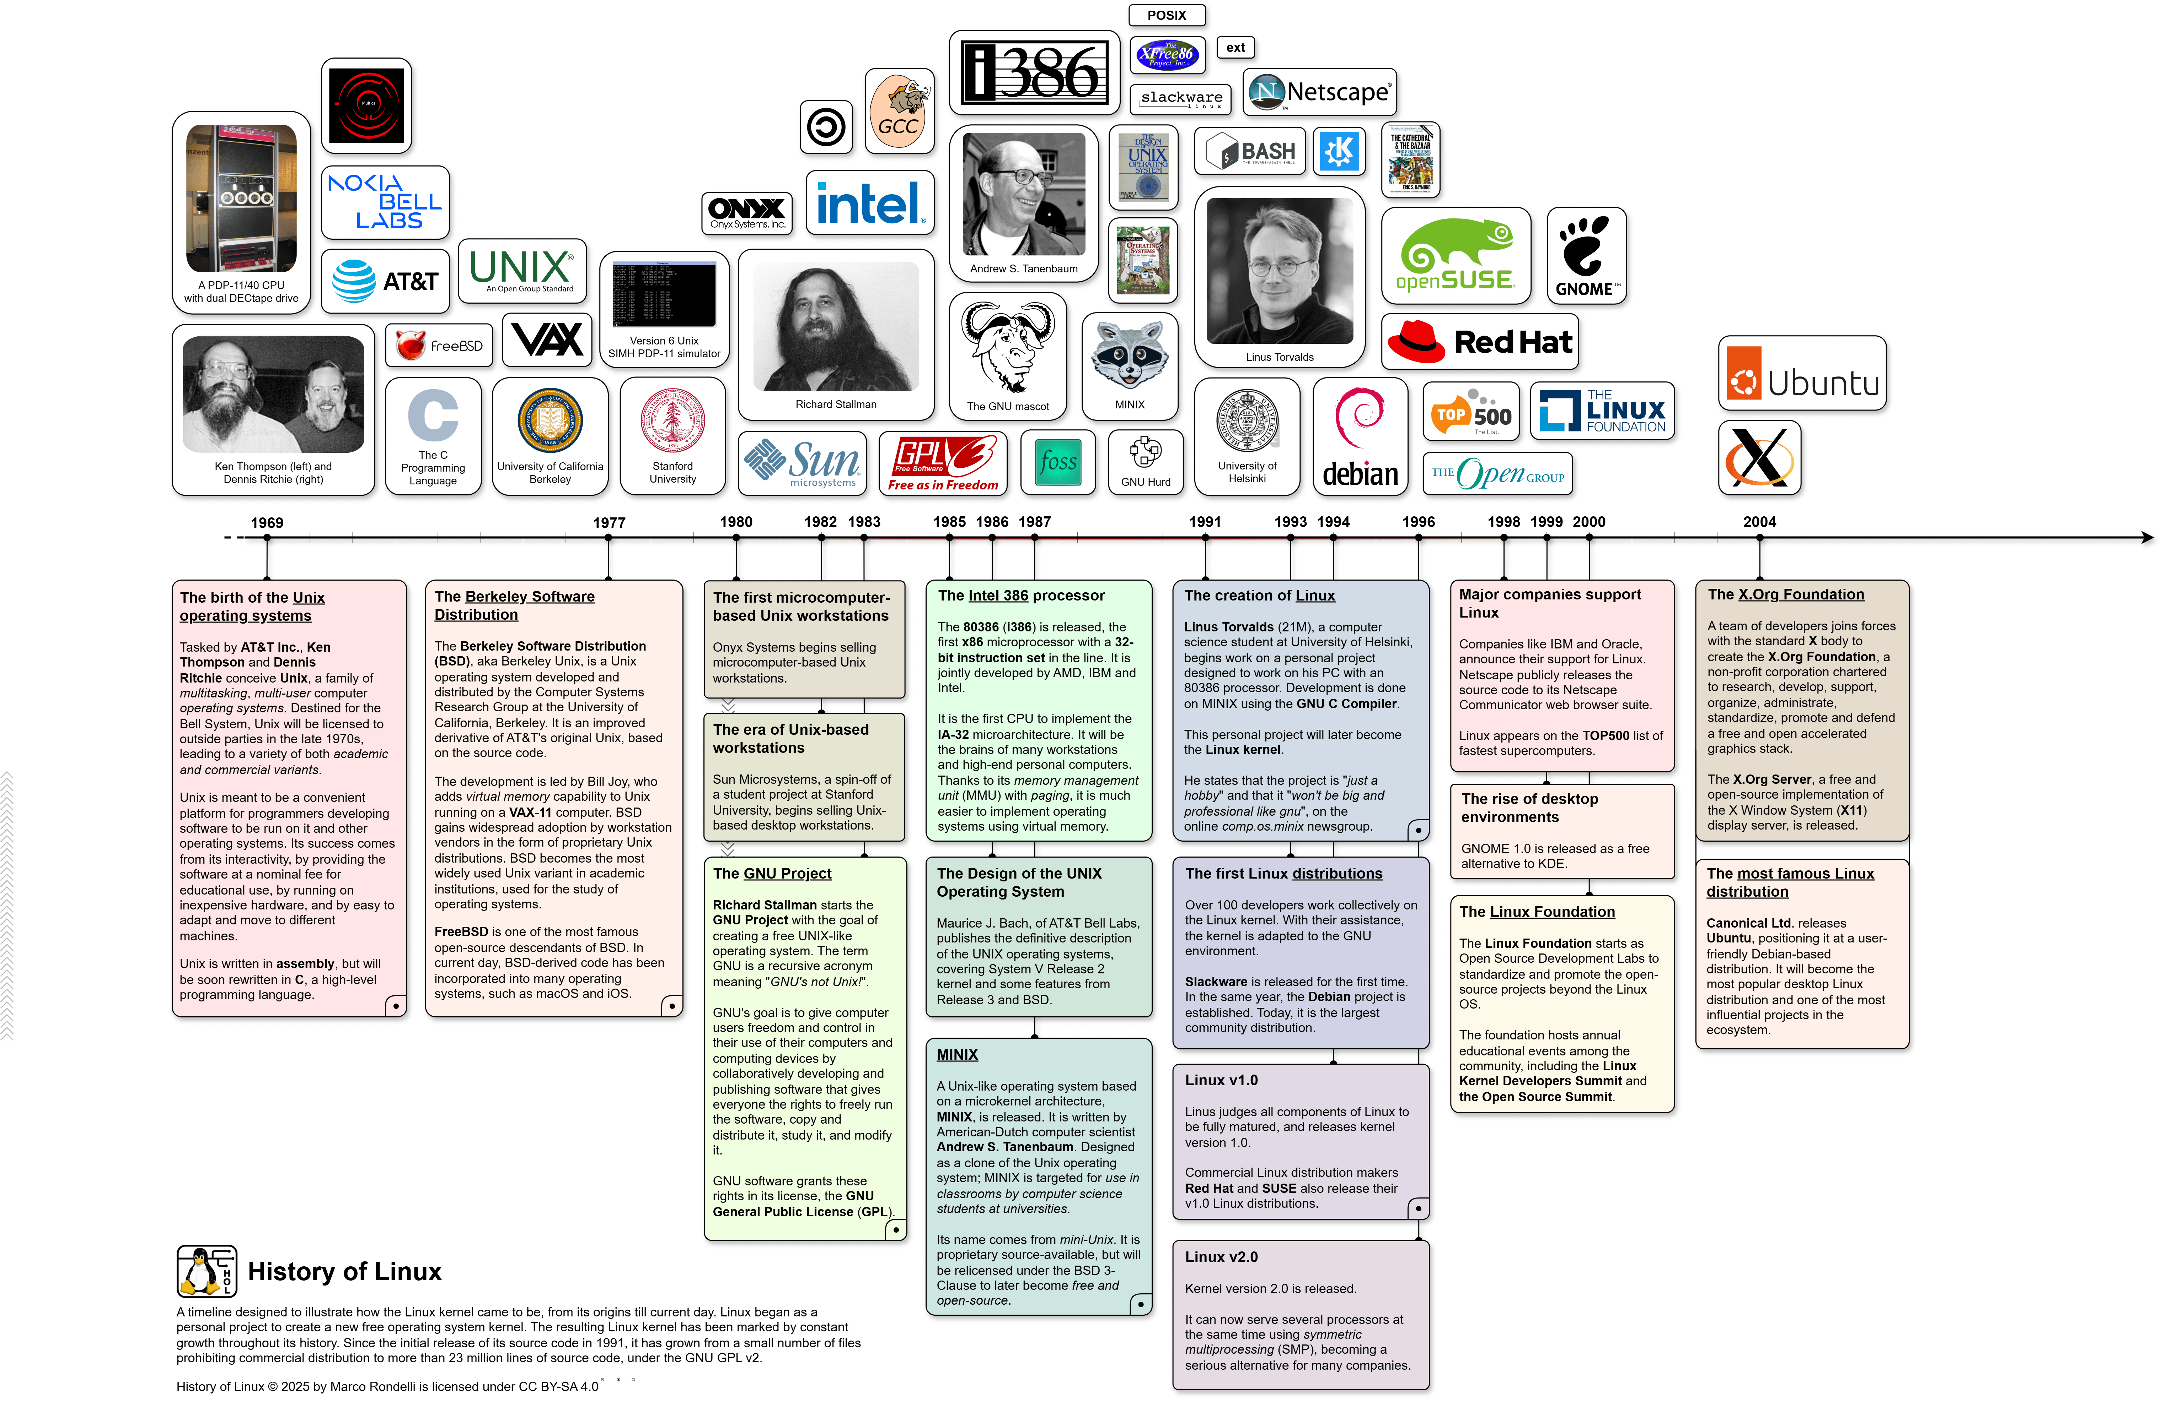
Origins of Linux and GNU/Linux
The Linux kernel alone does not constitute a complete operating system; it relies on additional system utilities, libraries, and tools to function effectively. These components are largely provided by the GNU Project, which was initiated by Richard Stallman in 1983 with the goal of creating a completely free Unix-like operating system. While the GNU Project developed essential tools such as compilers, shells, and system utilities, it lacked a functional kernel. The introduction of the Linux kernel filled this gap, resulting in a fully operational system commonly referred to as GNU/Linux. This combination represents the successful integration of free software components and highlights the importance of both GNU tools and the Linux kernel in delivering an open and flexible computing environment.
Overview of Ubuntu, Fedora, and CentOS
Ubuntu, Fedora, and CentOS are three widely used Linux distributions, each designed to address different user needs and system requirements. Although they are all built on the Linux kernel and follow open-source principles, they differ significantly in usability, update frequency, stability, and target audiences.
Ubuntu, developed and maintained by Canonical, is known for its user-friendly design, strong community support, and extensive documentation. It follows a regular release cycle and offers Long-Term Support (LTS) versions that receive security updates and maintenance for several years. These features make Ubuntu an ideal choice for beginners, developers, educational institutions, and enterprise environments. Ubuntu is widely used in cloud computing, software development, and desktop systems due to its ease of installation, large software repository, and strong compatibility with modern hardware and applications.
Fedora is a community-driven Linux distribution sponsored by Red Hat and is recognized for its focus on innovation and cutting-edge technology. It frequently introduces the latest software versions, system enhancements, and security features. Fedora serves as the upstream project for Red Hat Enterprise Linux (RHEL), meaning that many of its technologies are tested and refined in Fedora before being adopted in enterprise environments. Due to its frequent updates and advanced features, Fedora is well-suited for developers, system administrators, and users who want early access to modern Linux technologies.
CentOS, traditionally known as Community Enterprise Operating System, is derived from the source code of Red Hat Enterprise Linux. It is designed to provide enterprise-grade stability and reliability without the cost associated with commercial support. CentOS prioritizes long-term stability over frequent updates, making it a popular choice for servers, data centers, and production environments. Its predictable performance and long support lifecycle reduce maintenance efforts and system downtime, making it ideal for critical enterprise applications.
Conclusion
Linux, along with its various distributions, provides a flexible, secure, and powerful operating system ecosystem. Ubuntu emphasizes ease of use and accessibility, Fedora focuses on innovation and modern features, and CentOS prioritizes stability and enterprise reliability. Together, they demonstrate the adaptability of Linux across a wide range of computing environments, from personal desktops to large-scale enterprise and cloud infrastructures.

